1. **Women security (camera module): -**

**Introduction:**

Women's security is a critical issue that requires attention at all levels of society. So we developed women security camera device with cloud storage and emergency alert. it can be use as safety device whenever woman feel unsafe. There are several security camera devices available in the market that can help improve women's safety and security. carrying personal protection devices such as pepper spray, a personal alarm, or a self-defense keychain is necessary now day. In this device, there is feature to Report any suspicious activity to the authorities immediately. For this purpose, we had used ESP32 cam module. Our security camera offers high-quality and image resolution. This will help ensure that any suspicious activity can be captured clearly and accurately. security camera devices offer cloud storage, which will store recorded footage in a secure online location. This can be useful in case the camera is stolen or damaged. it can be installed quickly and easily by the user.

**Feature:-**

camera that can captures a continuous stream of images and then allows you to upload the previous six images with the press of a button. This feature can be useful in situations where you want to capture a sequence of images, but only need to upload a few of them. the camera would need to continuously capture images and store them in a buffer. When the user presses the upload button, the camera would retrieve the previous six images from the buffer and initiate the upload process. The camera could then clear the buffer to make room for new images.

This feature can be implemented by following way;

1. Set up a buffer to store the captured images.
2. Configure the camera to capture a continuous stream of images at a specified interval.
3. Set a limit on the number of images that can be stored in the buffer (e.g. six images).
4. When the buffer is full, discard the oldest image and add the newest image to the buffer.
5. When the user presses the upload button, retrieve the previous six images from the buffer and initiate the upload process.
6. After the images have been uploaded, clear the buffer to make room for new images.

**Components used in this project: -**

1. **Esp32 cam**

ESP32-CAM is a popular development board based on the ESP32 chip, which features an integrated camera module. This board can be used for a wide range of applications that require wireless connectivity and image processing capabilities, such as video streaming, security systems, and remote monitoring.

Silent features:-

1. ESP32 chip with Wi-Fi and Bluetooth connectivity
2. OV2640 camera module with 2MP resolution
3. MicroSD card slot for storing images and videos
4. Built-in USB to serial converter for easy programming and debugging
5. Multiple GPIO pins for interfacing with other sensors and devices
6. On-board voltage regulator and power management circuitry

We used the Arduino IDE and the necessary libraries for the ESP32 chip. Once we installed the software, we can upload code to the board and interact with the camera module using the appropriate commands.

1. **FTDI:-**

FTDI stands for Future Technology Devices International, a company that designs and manufactures integrated circuits (ICs) for USB connectivity and communication. FTDI ICs are commonly used in a variety of electronic devices and systems that require USB connectivity, such as microcontrollers, sensors, and other embedded systems.

One of the most popular FTDI ICs is the FT232RL, which is a USB-to-serial converter chip. This chip allows a microcontroller or other device with a serial interface to communicate with a computer over USB. The FT232RL chip can be connected to a microcontroller's UART (Universal Asynchronous Receiver/Transmitter) interface, allowing the microcontroller to send and receive data over USB.

1. **SD card:-**

An SD card (Secure Digital card) is a type of memory card used for portable electronic devices such as digital cameras, smartphones, tablets, and portable media players. It is a small, portable storage device that can be easily inserted and removed from a device, allowing for the transfer of data between different devices. In our case we used it as for local image storage. For SD card we can upload the images in firebase storage.

1. **Cloud storage: -**

As a server storage, we had used firebase storage. Firebase Storage is a cloud-based storage service offered by Google's Firebase platform. It provides secure and scalable file storage for your web or mobile application, allowing you to store and serve user-generated content such as images, videos, and other files.

1. **Software:-**

ESP32-CAM is a low-cost development board that combines an ESP32-S chip with a camera module, making it easy to build a small-scale security camera system using advance level of c and c++ coding. For the functionality of this security device the code is core source. We developed our own code using following libraries.

#include <Firebase_ESP_Client.h>

#include "esp_camera.h"

#include "Arduino.h"

#include "SD_MMC.h"

#include <WiFi.h>

The ESP32-CAM software includes the firmware for the ESP32 chip as well as the software to control the camera module. The ESP32 chip runs on firmware that provides low-level functionality such as Wi-Fi connectivity, memory management, and power management. The ESP-IDF (ESP32 IoT Development Framework) is the official firmware for the ESP32 and provides a range of APIs and libraries for building IoT applications. The ESP32-CAM software includes the software to control the OV2640 camera module, which provides a range of features such as image capture, image processing, and streaming. The software uses the camera interface provided by the ESP32 chip and is usually based on the OV2640 driver library. The ESP32-CAM has built-in Wi-Fi connectivity, and the software includes the necessary networking libraries to connect to a Wi-Fi network, set up a web server, and communicate with other devices over the internet. Depending on the specific application, you may need to include additional software components such as sensors, storage, or control interfaces. The ESP-IDF provides a range of libraries and examples for working with these components.

**Project output:-**

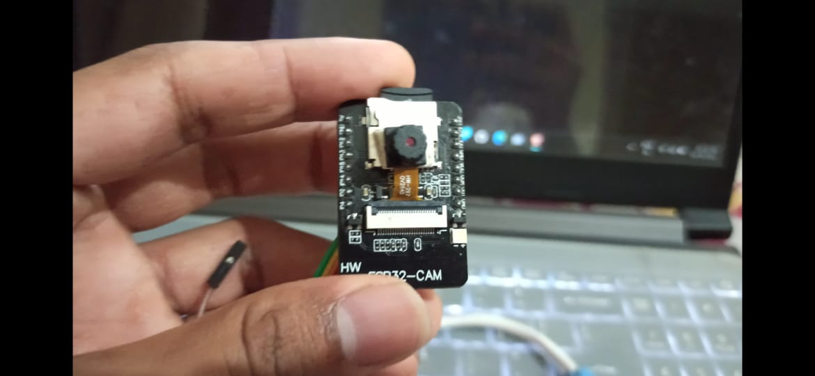

**Future Scope : -**

The ESP32-CAM has already been used for building small-scale security cameras, but there is potential for developing more advanced features such as facial recognition, object detection, and intelligent alert systems. The ESP32-CAM can be integrated with other IoT devices to create smart home systems that can be controlled remotely through a mobile app or voice commands. It can also be used for applications such as home automation, energy management, and environmental monitoring. The ESP32-CAM's low cost and small size make it an attractive option for building robots and drones that require camera functionality. It can be used for tasks such as image processing, object tracking, and obstacle detection. The ESP32-CAM can be used for medical applications such as remote patient monitoring, telemedicine, and diagnostics. It can also be integrated with other medical devices such as sensors and wearables for more comprehensive health monitoring. The ESP32-CAM is an excellent platform for learning and experimenting with electronics and programming. It can be used for educational purposes such as teaching coding and robotics, and for DIY projects such as building a custom camera or creating a smart mirror.

**REFERENCE:-**

1. Random nerd tutorials
2. **Device to detect sponge during Surgical procedure.**

**Category: Biomedical**

**Level: UG**

**Abstract:**

Every surgical item used during surgery (e.g., sponges) must be accounted for after surgery to ensure that none of these items is left inside the patient as that may lead to inflammation, sepsis, and sometimes death. The problem is avoidable by manual counting guidelines by Operating-Room(OR). Despite the numerous precautions in place, in approximately 1 in 1500 cases, something gets left behind inside the patient’s body.

**Introduction of Work:**

Human error is not the only drawback. During sponge counting, nurses are unable to provide support for the surgeon as they are focused on accurately three counts per procedure. Under these counting procedures, the nurse is inevitably distracted from her primary role for a significant part of the time. Also, when a miscount is found, there is a significant increase in the OR time since an x-ray of the patient is many times required, also requires a radiologist to be available after every procedure.

In this project, I used metal detector technology. And build 3 different metal detectors. As we required more precise and high accuracy device. It requires more study about metal detector functionality. The functionality of a metal detector is based on the principle of electromagnetic induction. The metal detector generates a magnetic field using an oscillator circuit that is composed of a coil of wire. This magnetic field interacts with metallic objects nearby, inducing eddy currents in the metal. These eddy currents in turn generate their own magnetic field that interacts with the magnetic field of the detector. This causes a change in the amplitude and frequency of the magnetic field of the detector, which can be detected by a receiver circuit. The metal detector is calibrated to detect changes in the amplitude and frequency of the magnetic field caused by metal objects. When a metallic object is detected, the metal detector produces an audio or visual signal to alert the user. The user can then use the metal detector to locate and retrieve the metal object.

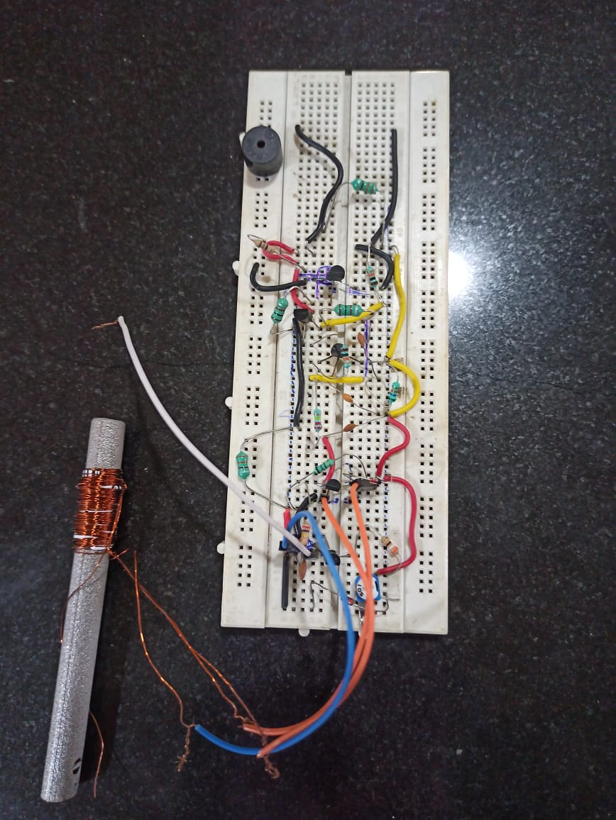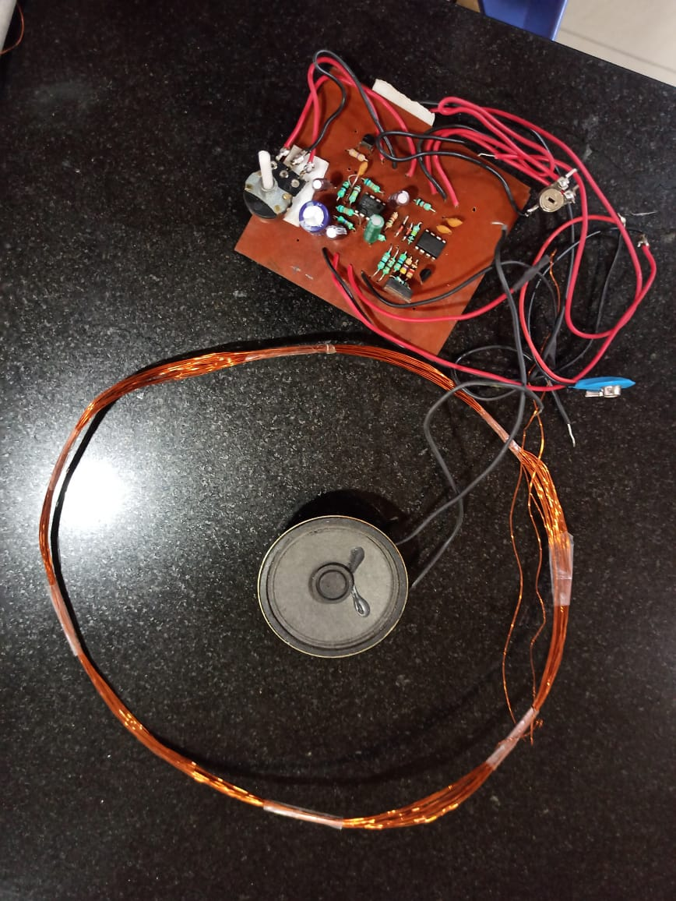**Modules :-**

**Conceptual Diagram**

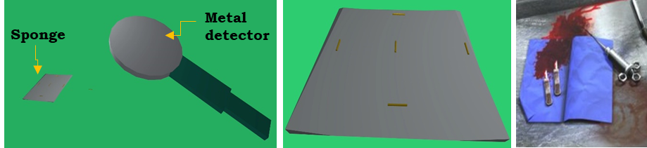

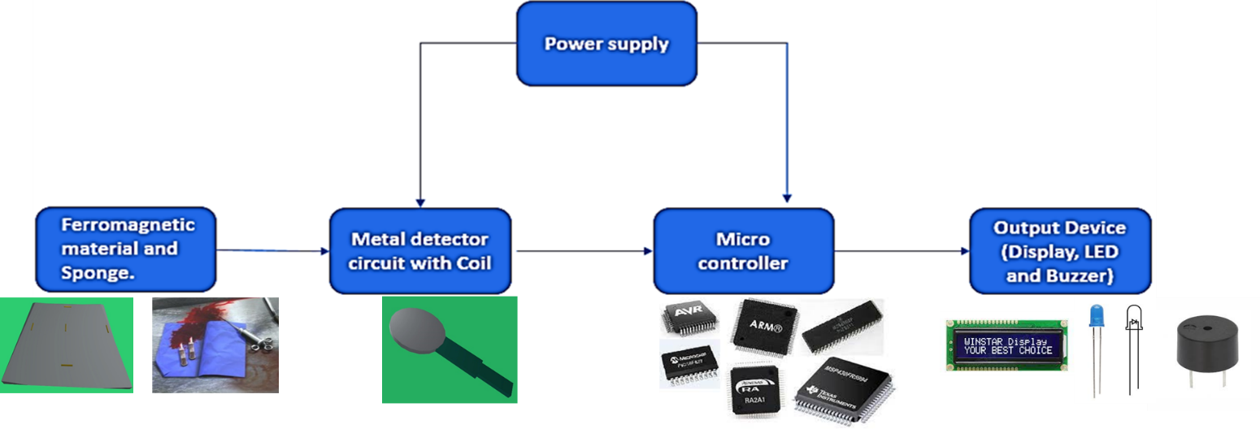 **Detailed project diagram:-**

**Advantage:**

1. Eliminates false-positives, i.e., counts that appear to be complete when a sponge is still missing.

2. Eliminates unnecessary exposure patients to x-rays.

3. it reduces the operational cost.

**Applications:-**

Use in hospital during every surgical procedure.

**Results: -**

1. it detects leftover sponge, knife, pin etc. during surgical procedure before stitching.
2. It also able to count the sponges after stitching, i.e., collected used sponges.

**Conclusion: -**

1. With proposed device, patients life can be saved due to medical staff error in surgery.
2. It is life saving device**.**

**Reference: -** 1. <https://pubmed.ncbi.nlm.nih.gov/18771206>2.<https://clinicaltrials.gov/ct2/show/NCT02111980>